Mini Project Report on:

Dentist Appointment System

Presented by:

Susmita Gawde – 21

Juwairiyah K. Zia – 32

Certificate

This is to certify that the project entitled **Dentist Appointment System** has been carried out by **Susmita Gawde & Juwairiyah K. Zia** under my guidance during the academic year 2018.

---------------------------- ----------------------------

Internal Guide Internal Guide

**INDEX**

1. INTRODUCTION
2. Introduction of the project
3. Problem definition
4. Object of project
5. Project scope
6. LITERATURE SURVEY
7. Existing system
8. Proposed system
9. ANALYSIS
10. Feasibility analysis
11. Diagrams
12. METHODOLOGY
13. Criteria & constraints
14. Tools used
15. DESIGN AND DEVELOPING A PROTOTYPE
16. Data design
17. Model used
18. TESTING & VALIDATION
19. Test cases & report
20. USER MANUAL
21. Forms
22. Output screens
23. CONCLUSION
24. **INTRODUCTION**
25. **Introduction of the project:**

Dentist Appointment System is an important way to see a doctor. This new system was developed using HTML, CSS as the development environment and MySql as the database to store the appointment data. The system consists of several data operation functions including appointment registration, data management, and schedule appointment.

The project supports to administrator to access complete application, Patient takes appointment through Online and receptionist approves patient’s appointment. This project is developed using PHP as Front End and MySQL server as backend. PHP is a server-side, cross-platform, HTML-embedded scripting language.

1. **Problem definition:**

The system has been facing problems due to its paper-based appointment system. With the increase in the number of patients visiting, it has become difficult to manage the appointment system manually. Recording of appointments and creating registers by pen and paper has become a tedious task. And also it’s difficult to manage huge number of patient database.

This application gives solution to the dentist patients and employees. This system which manages complete medico patient’s details in a single application and in a single database. The users will use this system to handle all the functionalities easily. Receptionist will also use the system to keep track of the patients consulting to them. The intentions of the system are to increase the number of patients that can be treated accurately.

1. **Project objective:**

* The proposed system is a website that will be easy to use for users of all ages.
* It manages all patient’s related information.
* Easy to book an appointment from anywhere online.
* Reduce paper work to manage an appointment details.
* It is easy to schedule an appointments for receptionist.
* It gives security to patient’s information.
* Patient can get doctor’s schedule details, so according to that they can book an appointment.

1. **Project Scope:**

The main scope of this project is, users don’t have to visit the clinic manually. Reports will be generated online, users don’t have to collect it manually. Time slots are available online, through which user can easily book it.

1. **LITERATURE SURVEY**
2. **Existing System:**

The system has been facing problems due to its paper-based appointment system. With the increase in the number of patients visiting, it has become difficult to manage the appointment system manually. Recording of appointments and creating registers by pen and paper has become a tedious task. And also it’s difficult to manage huge number of patient database.

1. **Proposed System:**

This application gives solution to the dentist patients and employees. This system which manages complete medico patient’s details in a single application and in a single database. The users will use this system to handle all the functionalities easily. Receptionist will also use the system to keep track of the patients consulting to them. The intentions of the system are to increase the number of patients that can be treated accurately.

1. **ANALYSIS:**
2. **FEASIBILITY ANALYSIS:**

* **Technical Feasibility:**  
   The current system developed is technically feasible. It provides an easy access to users. It provides technical guarantee of accuracy, reliability and security. As the administrator is well versed in using a computer, so no extra knowledge needs to be imparted. Since, the administrator already has a PC with the necessary system requirements; it does not require any additional hardware or software.
* **Economic Feasibility:** The system is economically feasible. Since, the administrator already has a PC with the necessary system requirements; it does not require any additional hardware or software. So, no extra costs are needed to be incurred. The anticipated values of benefits will be definitely greater than project cost of development. The economic feasibility also deals with whether the organization has enough economic support since this system will be developed in less amount of time. The overall amount cost will be very low.
* **Operational Feasibility:**

The new system as to be design to have a strong user interface that requires minimum training to operate the system. The system will be operational. Since it will be replacing all manual works by automated work and also the organization will be ready to accept the proposed system considering into operational feasibility.

1. **Diagrams:**

* **ER Diagram:**

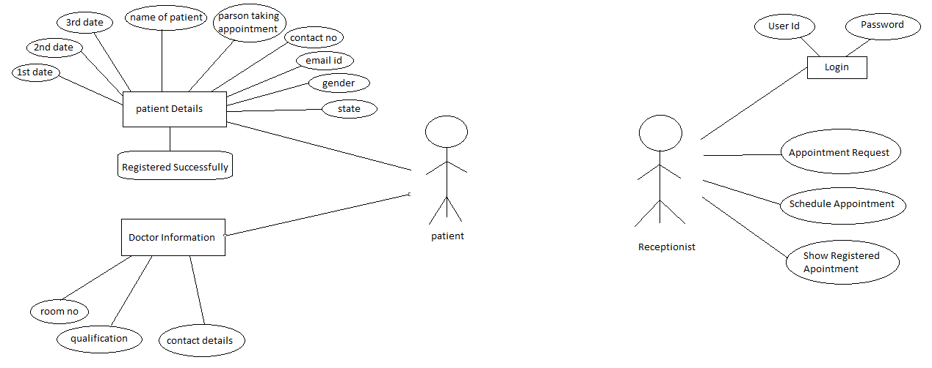

* **DFD Diagram:**

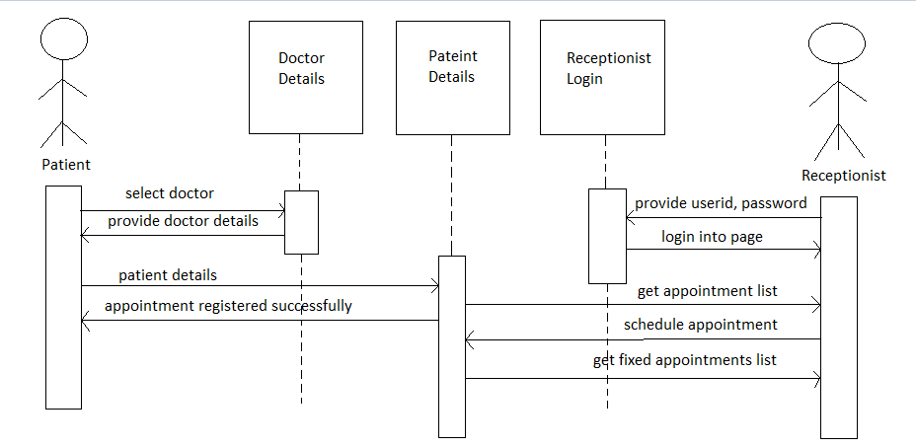

1. **METHODOLOGY:**
2. **CRITERIA & CONSTRAINTS:**

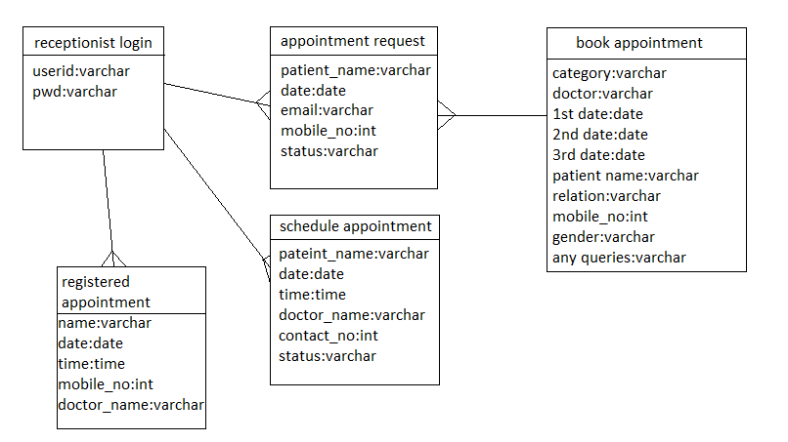

1. **TOOLS USED:  
     
   2.1 Hardware Requirements:**
   1. Dial-up connection.
   2. Pentium IV or higher processor
   3. 2 GB RAM.
   4. Modem

**2.2 Software Tools Details:**

1. Company side server connected to World Wide Web (WWW).
2. Client side: - Internet connection is required for supported web.
3. Browser (I.E.3x, NC 3.x).
   1. **Technology Used:**
4. Front End: HTML and CSS
5. Back End: Php with Myadmin
6. Database: MYSQL
7. **Design and developing a prototype:**

1. **Data Design:**
2. **Model:**
   * + 1. **Waterfall Model:**

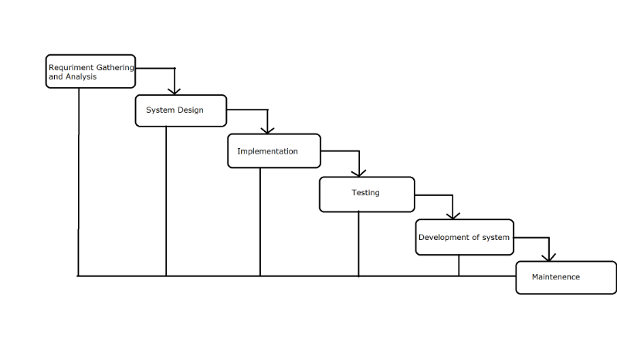

The sequential phases in the Waterfall Model are:

* **Requirement Gathering and Analysis:**   
   All possible requirements of the system to be developed are captured in this phase and documented in a requirement specification doc.
* **System Design:**   
   The requirement specifications from first phase are studied in this phase and system design is prepared. System Design helps in the specifying hardware and system requirements and also helps in defining overall system architecture.
* **Implementation:**   
   With inputs from system design, the system is first developed in small programs called units, which are integrated in the next phase. Each unit is developed and tested for its functionality which is referred to as Unit Testing.

**Integration and Testing:**   
 All the units developed in the implementation phase are integrated into a system after testing in of each unit. Post integration the entire system tested for any faults and failure.

**Deployment of system:**   
 Once the functional and non-functional testing is done, the product is deployed in the customer environment or released into the market.

**Maintenance:**   
 There are some issues which come up in the client environment. To fix those issues patches are released. Also to enhance the product some better versions are released. Maintenance is done to deliver these changes in the customer environment. All these phases are cascaded to each other in which progress in seen as flowing steadily downwards (like a waterfall) through the phases. The next phase is started only after the defined set of goals are achieved for previous phases and it is signed off, so the name “Waterfall Model”. In this model phases do not overlap.

**Waterfall Model Application:** Every software developed is different and requires a suitable SDLC approach to be followed based on the internal and external factors. Some situations where the use of Waterfall model is most appropriate are: Requirements are very well documented, clear and fixed. Product definition is stable. Technology is understood and is not dynamic. There are no ambiguous requirements. Ample resources with required expertise are available to support the product. The project is short.

**ADVANTAGES:**

* The advantage of waterfall development is that it allows for departmentalization and control.
* A schedule can be set with deadlines for each stage of development and a product can proceed through the development process model phase one by one.
* Development moves from concept, through design, implementation, testing, installation, troubleshooting, and ends up at operation and maintenance.
* Each phase of development proceeds in strict order.

**DISADVANTAGES:**

* The disadvantage of waterfall development is that it does not allow for much reflection or revision.
* Once an application is in the testing stage, it is very difficult to go back and change something that was not well-document or through upon in the concept stage.

1. **Testing & validation:**
2. **Test cases:**

1. **USER MANUAL:**
2. **Forms:**
3. **Output Screenshots:**
4. **CONCLUSION:**

Dentist Appointment system is designed and developed to fulfil the necessary requirements and demands of the patients to book an appointment on the date and time they needed. The system developed has form level validation and works very efficiently.

The new computerized system helps many people to access resources quickly and is also time saving. The system has been developed step and step and tested so as to meet basic needs. It is helpful for all as and when they required.

The system is developed with secure features and also has quick retrieval of information from database.

The present system is totally depending on manual data management for different activities such as booking an appointment, retrieving the appointed data, updating the data, etc. System can efficiently perform various transactions such as adding, updating and maintain data after each transaction. In short proposed system is user-friendly.